Johnny Mak (40002140)

Comp 476 – Advanced Game Development

Assignment #3

Write-up

**Controls:**

* W: Move tank forward
* A: Rotate tank towards the left
* S: Move tank backward
* D: Rotate tank towards the right
* Space: Fire Round from tank

**Power-ups:**

There are two powerups in the game. There is a distinct different between the two powerups. One spinning round have a Red tip, while the other has a yellow one. The assignment has specified to place them in each corner of the map, but for balancing reasons, I have decided to place them in hard to reach places based on preset spawns.

* **Red Tip Power-up**: When the tank comes in contact with this power-up, the player will be granted unlimited shots with no delay for a total of three seconds after activating it. The rounds fired from this power-up is the exact same as regular rounds. It only temporarily increases the fire rate.

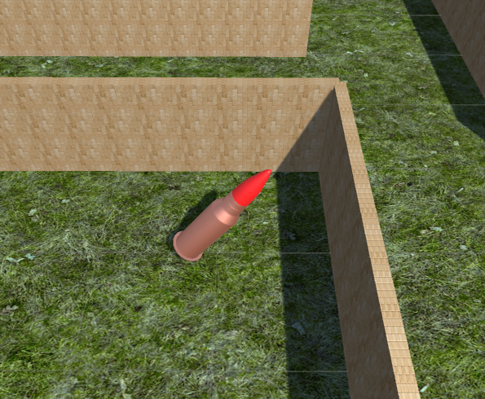

* **Yellow Tip Power-up**: When the tank comes in contact with this power-up, the player will be granted one massive shot. The round shot from this power-up is four times the size of a regular shot. In addition, the round does not stop upon collision, but continues to bounce around at a random angle until it reaches the outer wall, destroying everything in between. However, due to balancing, it will not destroy an enemy tank in a single shot.

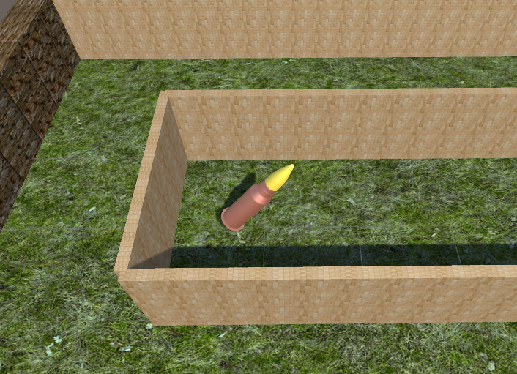

**Game Rules:**

In this game, there can be a maximum of two players. In order to eliminate the other player, you will have to shoot them. It will require at least **three** direct hits with any kind of rounds to destroy them. Player can grab power-ups by simply moving into it. Once the power-ups are used, it will not respawn.